Please answer all questions as a group. Please distribute questions amongst your group as evenly as reasonably possible. Compile your answers in one final document and attach this to the discussion group posting for week 2. This will be available later today.
This is due at 10:00PM, Tuesday January 22. When you submit your final document be sure to include the person’s name who answered it beside each question.

Use the class notes and internet to find your answers.

Section 1: Review Questions
1. In 4 lines or less (or lose marks) define each of the following:
- Unary relation (Give an example and show an ERD diagram)

A unary relation occurs when a table references itself. For example, employee’s supervisor attribute in the employee table may reference the same table.
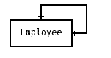
Correction: Manager could have many employees.

- Schema
The structure of a database is called schema. In a relational database, the schema defines the tables, the fields in each table, and the relationships between fields and tables.

- Data definition language
A database analyst designs the structure of the data in terms of entities, records, attributes, relationships between entities, and constraints. Data definition language physically establishes the entities, rows, fields, and structural relationships.

2. The next series of questions use the following tables:
TRUCK
TNUM | BASENUM | TYPENUM | TMILES | TBOUGHT | TSERIAL
1001 | 501 | 1 | 5900.2 | 11/08/90 | aa-125
1002 | 502 | 2 | 64523.9 | 11/08/90 | ac-213
1003 | 501 | 2 | 32116.0 | 09/29/91 | ac-215
1004 |  | 2 | 3256.9 | 01/14/92 | ac-315

BASE
BASENUM | BASECITY | BASESTATE | BASEPHON | BASEMGR
501 | Dallas | Tx | 893-9870 | J.Jones
502 | New York | NY | 234-7689 | K.Lee

TYPE
TYPENUM | TYPEDESC
1 | single box,double axle
2 | tandem trailer,single axle

- List the primary and foreign keys for each table.
Truck table:Primary key is TNUM. Foreign keys are BASENUM and TYPENUM
Base table: Primary key is BASENUM
Type table: Primary Key is TYPENUM

- Do the tables exhibit entity integrity? Explain why.
Yes. Each table’s Primary key is in minimal form and uniquely identifies each row. Each Primary key’s attribute value will be unique and not null, ensuring records can never be duplicated.

- Draw the ERD to show the relationship and cardinality for these tables.
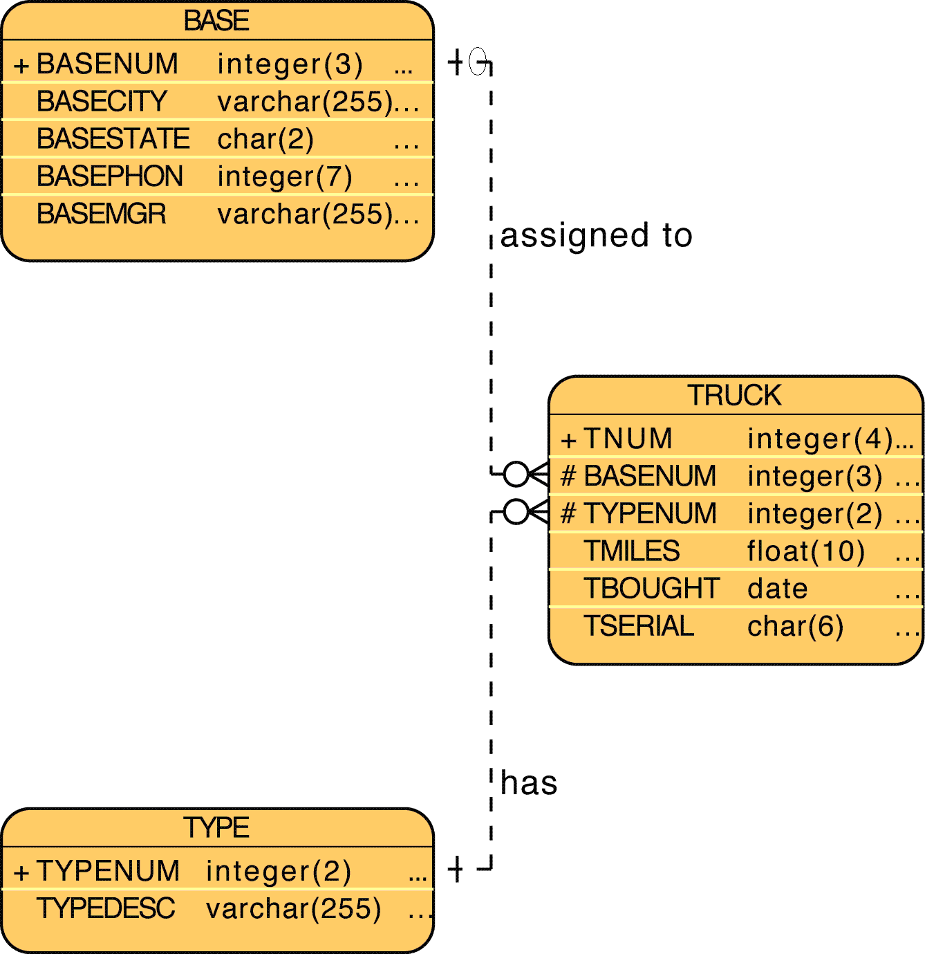
- Does these tables exhibit referential integrity? Explain why.
It shows referential integrity through keeping the rules for primary and foreign keys between tables valid. The Type table use TYPEMUM PK to the Truck table TYPENUM FK and Base table BASENUM PK to Truck table BASENUM FK.

- Does these tables exhibit entity integrity? Explain why.
Freebie. Same as b ☺

3. Given the following diagram, what are the primary, foreign, and candidate keys?
Correction: Candidate could be primary
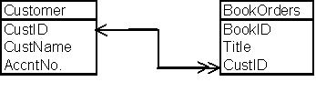
The primary keys are “CustID” within entity “Customer”, and “BookID” within entity “BookOrders”. The foreign key is “CustID” within “BookOrders”. The attribute “AccntNo” is a candidate key within “Customer”.

4.
a. Create an ERD to describe the relationship between an order that has multiple products. Each product only appears once on the order. However, the same product may be supplied by different manufacturers. Focus on the order, product, and manufacturer entities and be aware of the need for bridge entities. Do not include customer entities or pricing information or shipper information. Keep this relatively simple.
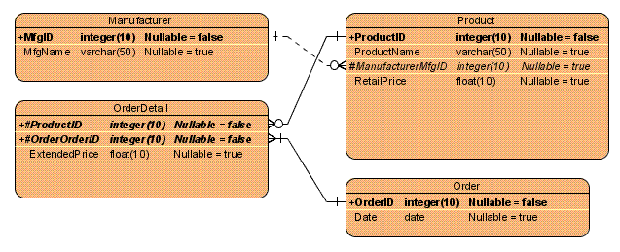
b. List the business rules for the ERD.
Manufacturer can have 0 or more products in the product table.
An instance of each product can only have one manufacturer

An order can only have one instance of each product.
A product can appear in 0 or many order details.

An order can have many products but must at least have one product.
Each detail on the order must belong to only one order.

c. Invent four different constraints for the data model that are not shown in the ERD or current business rules.

5. Draw an ERD for the following tables:
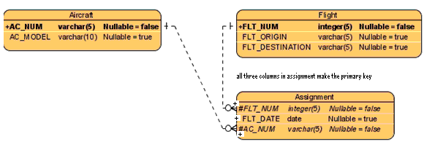
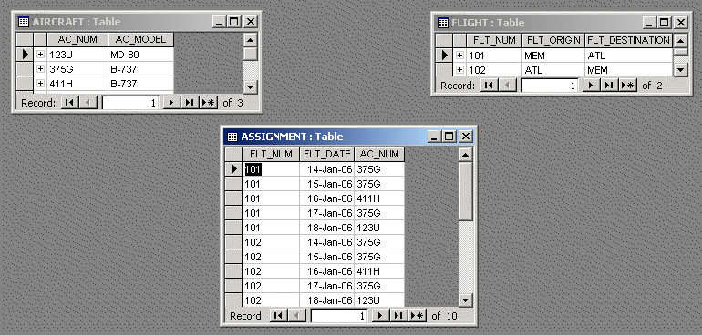

Section 2: Prep Questions for next class (also due Tuesday January 22)
6. Answer each question in 4 lines or less or lose marks.
a) What is a weak entity? Give an example.

A weak entity is an entity that cannot exist without the related entity. The weak entity primary key is derived from the parent entity in the relationship. For example, an order cannot exist without a customer.

b) What is a strong entity? Given an example.
A strong entity is an entity that can exist independently of any other entities. For example, a student table can exist independently from any other tables in a schema. In other words, a student doesn’t need a class, teacher, or course to exist before being registered as a student.

c) What is a weak relationship? Give an example.
A weak relationship occurs when the primary key of one entity does not include the primary key of a related entity. For example, a manufacturer and product table have a weak relationship if the manufacturer id is not included as part of the primary key in the product table.

d) What is a strong relationship? Give an example.
A strong relationship occurs when the primary key of one entity includes the primary key of a related entity. For example, a customer table and order table have a strong relationship if the order table uses the customerID as part of it’s own primary key.

7. Answer each question in 4 lines or less or lose marks.
a) What is a derived attribute?
It is a calculated field. Ie. Age = current date －birth date
b) What are two advantages of storing a derived attribute?
- Saves on processing time when viewing data.
- Useful for analyzing long term trends.

c) What are two advantages of not storing a derived attribute?
- Must continuously be updated
- Less space used

8. Draw the following ERD using UML notation:

